BIOS FOR 2026 PROGRAM
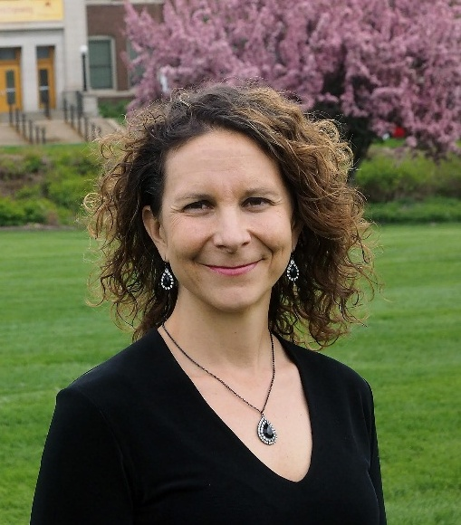
Sara Heger
University of Minnesota
Onsite Sewage Treatment Program
Research Engineer and Instructor
1985 Buford Ave, 173 McNeal Hall
St. Paul, MN 55018
Phone: 612-239-8918
Email: sfheger@gmail.com
Website: septic.umn.edu

Bio
Dr. Sara Heger is a researcher and instructor in the Onsite Sewage Treatment Program at the University of Minnesota, where she also serves as faculty in the Water Resources Science program. A former president of the National Onsite Wastewater Recycling Association, Dr. Heger has spent the past 25 years conducting research and delivering education and technical support to a wide range of audiences, including students, homeowners, small communities, onsite wastewater professionals, and local government agencies.

She leads the University of Minnesota’s onsite wastewater research program and contributes monthly articles to Onsite Installer and Pumper magazines. Her research focuses on applied research related to chlorides, decentralized wastewater treatment, and milkhouse wastewater treatment. Dr. Heger is an active member of the NSF International Committee on Wastewater Treatment Systems and currently chairs Minnesota’s Onsite Sewage Treatment System Advisory Committee. She received the Richard J. Otis Industry Achievement Award in 2025 for her significant work with NOWRA and within the onsite decentralized industry. She holds a B.S. in Biosystems and Agricultural Engineering, as well as an M.S. and Ph.D. in Water Resources Science.

BEN KELE 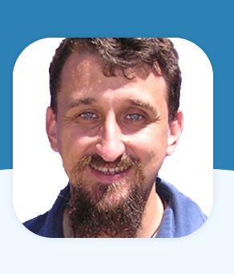
Ben Kele is an Australian onsite & decentralized wastewater treatment systems specialist. He has completed his Master's degree in Applied Science in onsite wastewater treatment and has high hopes of handing in his PhD thesis on this topic, if he can ever find the time to write it. Ben has patented technologies from his research. Ben has over 30 years of experience working in the sector, in a wide variety of roles ranging from septic tank construction to University lecturer & researcher. He is the Managing Director of Arris, a company that focuses on providing onsite & decentralized wastewater treatment options for difficult sites. He has a passion for working with interesting ways to treat effluents. He maintains that any splash you don’t taste is a good splash.
For more information on Ben, go to https://www.arris.com.au/water/our-team/

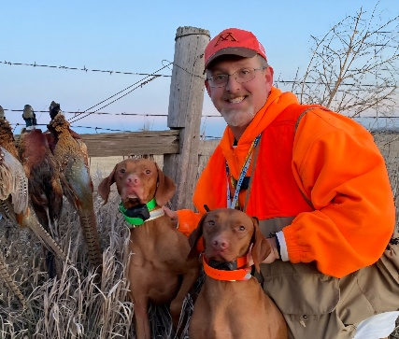
PETER OTTERNESS
He is the new Infiltrator Representative for the area – North Dakota and more. I’ve been in the septic industry since 2008 as a regulator and educator, and in wastewater and water testing since 1996. He looks forward to working all installers and the State association.

PERRY SULLIVAN
Professional Soil Classifier and chairman of the North Dakota Board of Professional Soil Classifiers

